Beach Kinder Snake Awareness Policy
NQS: Quality Area 2
This policy summarises some key points about snake awareness at our beach kinder program. It should be read in conjunction with all of the policies adopted by Flinders Preschool Inc.

Purpose
This policy aims to clearly define:
- The risk of snakes in the Beach Kinder space
- Procedures for preventing snake bite
- The appropriate medical response to snake bites
- A framework for the appropriate education and training of children, staff, parents and children on minimising the risk of snake bites.

Policy Statement

1. Values
Flinders Preschool is committed to:
- Providing a safe and healthy environment for children, staff and volunteers participating in the Beach Kinder program
- Being respectful of wildlife in and around the Beach Kinder space, including an awareness of the presence of snakes in the area in the warmer months
- Facilitating appropriate communication and education to staff, parents and children to minimise the risk of injury of a snake bite during Beach Kinder sessions.

2. Scope

This policy applies to children, parents, staff, committee members, authorised persons, volunteers and students on placement working at Flinders Preschool.

3. Background and legislation
Flinders Preschool’s Beach Kinder program is conducted on the beach next to parkland in which it is recognised to be a site where snakes may be active and present.
They are most prevalent in the warmer months (September to April) but could be encountered at other times.
Species of snakes that may be found in and around Flinders include brown snakes, tiger snakes, and copperheads. All snakes should be regarded as dangerous. However, if unprovoked, snakes rarely attack humans and are generally shy, timid animals that will void conflict if given the opportunity. It is recommended that particular care be taken in warm weather, near long grass or hollow logs, near water or rocks in sunny positions.
Snakes are protected under the Wildlife Act 1975, and should not be harmed or killed. Bites can occur if people try to kill snakes.
Relevant legislation may include but is not limited to:
- Education and Care Services National Regulations 2011
- Education and Care Services National Law 2010
- National Quality Standards, including Quality Area 2 – Children’s health and safety and Quality Area 3 – Physical environment
- Occupational Health and Safety Act 2004
- Occupational Health and Safety Regulations 2007
- Wildlife Act 1975

The most current amendments to listed legislation can be found at:
• Victorian Legislation – Victorian Law Today: http://www.legislation.vic.gov.au/
• Commonwealth Legislation – ComLaw: http://www.comlaw.gov.au/

4. Definitions
Australian Venom Research Unit (AVRU) is an internationally recognised interdisciplinary research unit focused on the problem of venomous injury in Australia and the Asia-Pacific. Located within Melbourne University, the Australian Venom Research Unit aims to provide world-class expertise on the problem of Australia's venomous creatures, their toxins and the care of the envenomed patient.

Pressure Immobilisation Bandage (also known as Compression Bandage): Bandage used for the purpose of applying pressure to the site of a wound such as a snakebite and to the affected limb. Refer definition below of Pressure Immobilisation Bandaging.

Pressure Immobilisation Bandaging: The principle of pressure-immobilisation bandaging as a first aid measure is to prevent the spread of toxins through the body. This is done by applying enough pressure to compress the lymph vessels, and by preventing movement of the affected limb. Correct application of the technique can buy valuable time to get the patient to medical assistance. [Refer to Attachment 1 for correct application of pressure immobilisation technique.

Victorian Poisons Information Centre (VPIC): Located at the Austin Hospital, the role of the VPIC is to provide the people of Victoria with a timely, safe information service in poisonings and suspected poisonings. For members of the public this includes telephone assessment, advice on first aid, with or without referral to a doctor or hospital. Information is given to health professionals about formulations of products and management of poisoned patients.

5. Sources and related centre policies

Bites & Stings web resource, Victorian Poisons Information Centre, Austin Health
Australian Venom Research Institute (University of Melbourne) first aid
Beachwalking Victoria Snakebite Walksafe brochure
- Beach Kinder Delivery & Collection of Children Policy (Beach Kinder Specific)
- Beach Kinder Protective Clothing Policy (Beach Kinder Specific)
- Beach Kinder Emergency Evacuation Policy (Beach Kinder Specific)
- Beach Kinder Extreme Weather Policy (Beach Kinder Specific)
- Administration of Medication
- Administration of First Aid
- Delivery and Collection of Children
- Incident, Injury, Trauma & Illness Policy
- Child Safe Environment and Wellbeing
- Excursions and Service Events
- Nutrition, Oral Health and Active Play
- Supervision of Children Policy
- Excursions and Service Events Policy
- Sun Protection Policy
- Water Safety Policy
- Supervision of Children
- Occupational Health & Safety Policy

Procedures
General

The Committee is responsible for:
- Supplying a First Aid Kit on site at Beach Kinder to administer first aid in response to snake bites or for any other purpose which includes pressure immobilisation bandages (also known as compression bandages) for medical treatment of snake bites.
- Ensuring staff are appropriately educated on procedures to prevent snakebite and to deliver First Aid in response to a Snake Bite (see below).
- Following all procedures as set out in the Injury Trauma and Illness Policy (including notice of notifiable incidents, appropriate record keeping in the event of an incident, maintain first aid kit etc)

Staff are responsible for:
- Practicing and educating children on snake bite prevention behaviours while at Beach Kinder, without fostering a fear or paranoia of snakes. This includes practising and highlighting to children the following key points:

Snake Bite Prevention Behaviours (Source: Victorian Poisons Information Centre, Austin Health)
- Leave snakes alone
- Wear adequate clothing and stout shoes (not sandals/thongs) in 'snake country'
- Never put hands in hollow logs or thick grass without prior inspection
- When stepping over logs, carefully inspect the ground on the other side
- Ensure children are reminded on a regular basis that if they encounter a snake, to move away quietly and report the sighting immediately to a teacher.
- In the event that a snake is encountered at Beach Kinder, calmly moving children away from the snake. [Staff must not attempt to touch or harm the snake].
- Administering first aid in the event of a snake bite
First aid for snakebite (Source: Victorian Poisons Information Centre, Austin Health, and Australian Venom Research Institute, Melbourne University))

- Stay calm and call for help. Have someone phone an ambulance. If unable to phone, send someone for help.
- Reassure the patient and encourage them to remain calm and still. Do not move the patient.
- Do not attempt to catch or kill the snake
- DO NOT WASH the bite. Traces of venom that are left on the skin can be used to identify the snake, and therefore the type of antivenom that should be used if required.
- Venom is injected deeply so there is no benefit in cutting or sucking the bite. A tourniquet is not an effective way to restrict venom movement.
- The most effective first aid for snakebite is the pressure-immobilisation technique. (Refer to Attachment 1 for instructions on the application of this technique). The principle is to minimise the movement of the venom around the body until the victim is in a hospital by applying a firm bandage (or suitable alternative) to the bitten area and limb, and to immobilise the victim. When applied properly, this method can trap the venom in the bitten area for many hours. The victim might not suffer any effects of the venom until the compression is released, which is done in hospital where antivenom can be administered if required.

- Staff are to follow procedures as set out in the Incident, Illness, Trauma & Illness Policy, including contacting parent, calling ambulance etc
- Reminding parents/guardians of the policy content as required

Parents are responsible for:
- Reading and being familiar with the policy
- Bringing relevant issues to the attention of both staff and committee

Volunteers and students, while at the service, are responsible for following this policy and its procedures.

Evaluation
In order to assess whether the policy has achieved the values and purposes the committee will:
- Seek feedback regarding this policy and its implementation with parents of children participating in the Beach Kinder program. This can be facilitated through discussions and the annual centre survey.
- Ask staff to share their experiences and observations in relation to the effectiveness of this policy.
- Review the first aid procedures following an incident to determine their effectiveness
- Regularly review the policy and centre practices to ensure they are compliant with any new legislation, research or best practice procedures.
- Revisit the policy and procedures in light of the above as part of the service’s policy review cycle, or earlier if required
- Notify parents/guardians at least 14 days before making any changes to the policy or its procedures (Regulation 172 of the National Regulations) unless a shorter period is necessary due to a perceived or actual risk

Attachments
Attachment 1: Pressure Immobilisation Technique (Detailed instructions with diagram on application of this technique in the event of a snake bite). Source: Australian Venom Research Institute (Melbourne University)

Authorisation
Endorsed by the Flinders Preschool Committee of Management on 19 March 2024.

Review Date
This policy will be reviewed every two years and is next due for formal Committee review in March 2026, unless deemed necessary earlier.
Next Review date – March 2026.

ATTACHMENT 1

Pressure Immobilisation Bandaging Fact Sheet
Source: Australian Venom Research Unit, University of Melbourne (www.avru.org)

The principle of pressure-immobilisation bandaging as a first aid measure is to prevent the spread of toxins through the body. This is done by applying enough pressure to compress the lymph vessels, and by preventing movement of the affected limb. Correct application of the technique can buy valuable time to get the patient to medical assistance.
First Aid for Bites to the Lower Limb
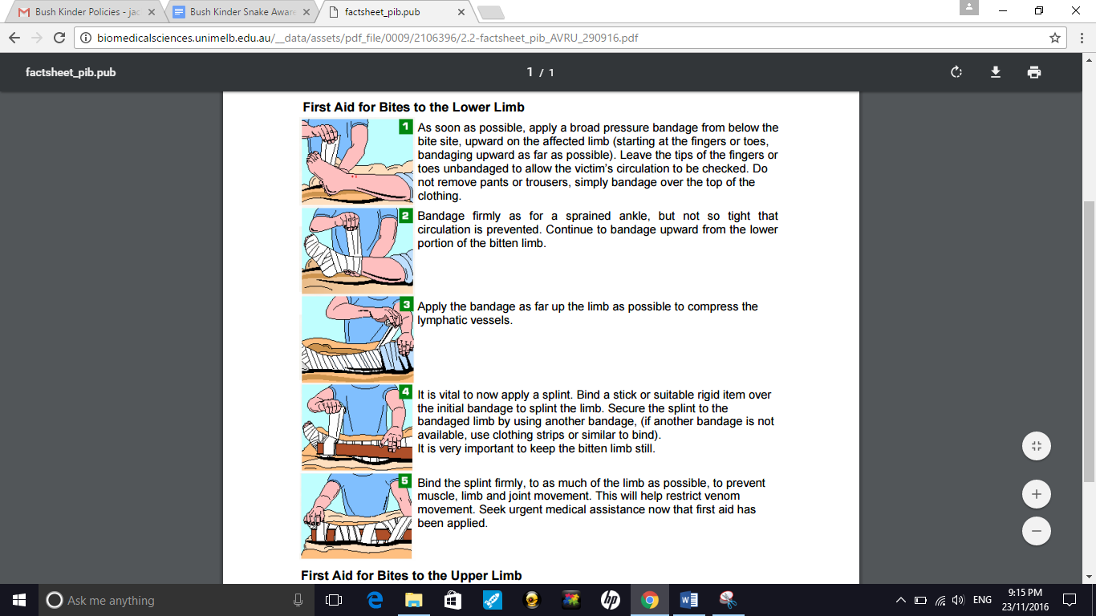 |  | As soon as possible, apply a broad pressure bandage from below the bite site, upward on the affected limb (starting at the fingers or toes, bandaging upward as far as possible). Leave the tips of the fingers or toes unbandaged to allow the victim’s circulation to be checked. Do not remove pants or trousers, simply bandage over the top of the clothing.
 |  | Bandage firmly as for a sprained ankle, but not so tight that circulation is prevented. Continue to bandage upward from the lower portion of the bitten limb
 |  | Apply the bandage as far up the limb as possible to compress the lymphatic vessels.
 |  | It is vital to now apply a splint. Bind a stick or suitable rigid item over the initial bandage to splint the limb. Secure the splint to the bandaged limb by using another bandage, (if another bandage is not available, use clothing strips or similar to bind). It is very important to keep the bitten limb still.
 |  | Bind the splint firmly, to as much of the limb as possible, to prevent muscle, limb and joint movement. This will help restrict venom movement. Seek urgent medical assistance now that first aid has been applied.

First Aid for Bites on the Hand or Forearm
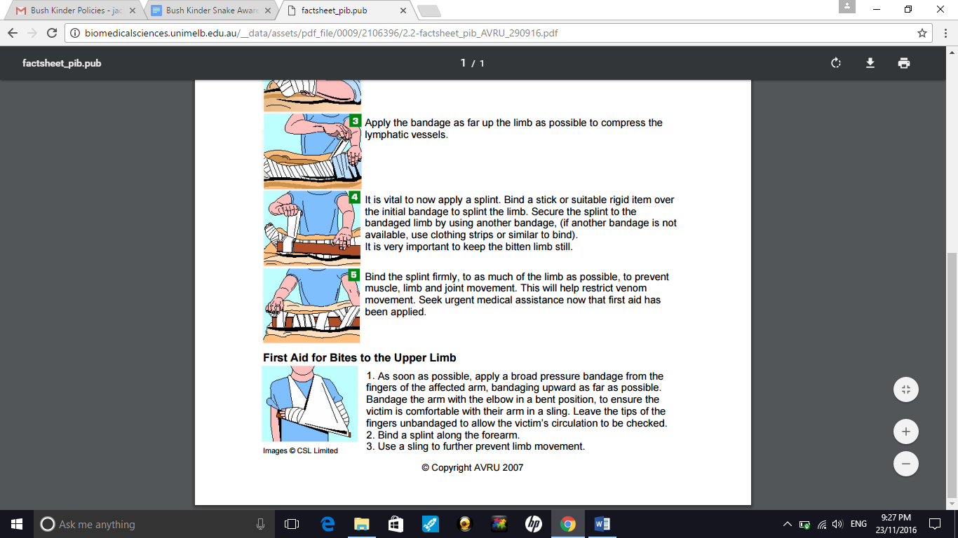 |  | 1 As soon as possible, apply a broad pressure bandage from the fingers of the affected arm, bandaging upward as far as possible. Bandage the arm with the elbow in a bent position, to ensure the victim is comfortable with their arm in a sling. Leave the tips of the fingers unbandaged to allow the victim’s circulation to be checked.  2 Bind a splint along the forearm.  3 Use a sling to further prevent limb movement.

